BLANKET APP DESIGN

STUDENT ID: 19025673

STUDENT NAME: ILYA KISELEV

MODULE CODE: UFCF7H-15-3

Requirements Analysis

Concept Brief

An app to help the user manage or correct their sleeping schedule.

As students this is something most of us can relate to; being terrible at keeping a regular or sufficient sleeping schedule.

Considering this it is astonishing to me to see the difference in brain processing 9 hours of sleep gives you compared to 5/6, and yet despite this most of us disregard good sleep. It is also important to keep a consistently regular sleep schedule at a good time during the night which the app should also promote.

Market Research

There are numerous apps with links to helping users achieve better sleep. Each one is unique with their own focuses, functionalities and flaws that I will attempt to point out. I will mainly look at the free features of the apps as they are the ones I have access to however will mention premium content if it contains a good feature.

Sleep Cycle: Sleep Tracker

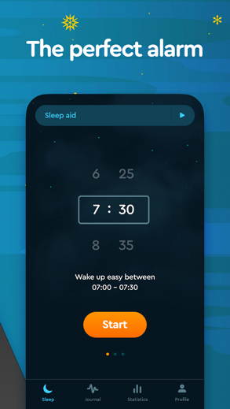 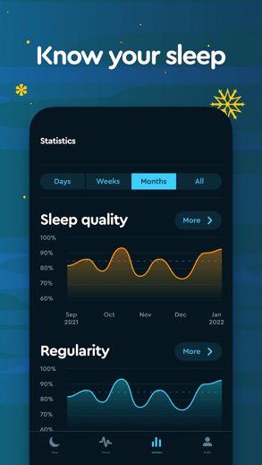

This app has customisable alarm melodies and time triggers to allow the user to have more or less jarring wake up depending on their setting. It also had a lot of statistics that it collects about the user’s sleep which it displays in fun graphs such as when the user has gone to bed and woken up over a time period.

Sleep Monitor: Sleep Tracker

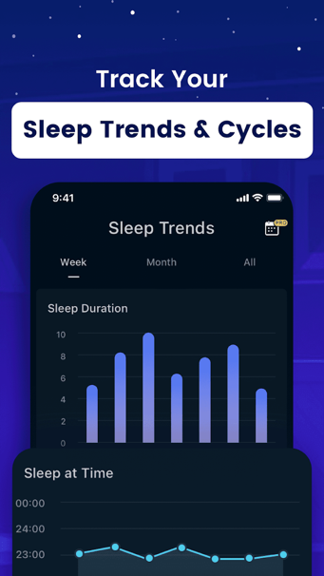 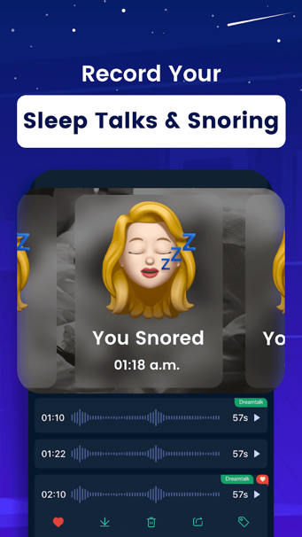

This app has very similar features to sleep cycle, the main difference I found was a higher focus on the statistics and the way that the collected information was presented. This app provided more views to display the information in more detail about specific factors that occurred during sleep such as REM cycles.

Sleep Cycle - Sleep Calculator Alarm Clock

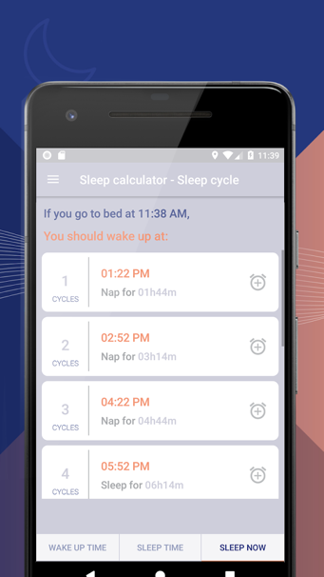 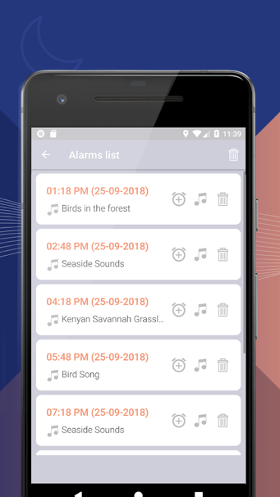

This app helps the user fall asleep and wake up in a more natural way, it calculates how long the user needs to sleep for to complete a full sleep cycle and provides pre-set alarm settings accordingly. It also has a number of customisable features to make the alarm be more natural through different audio options.

Sleep Time+: Sleep Cycle Smart Alarm Clock Tracker

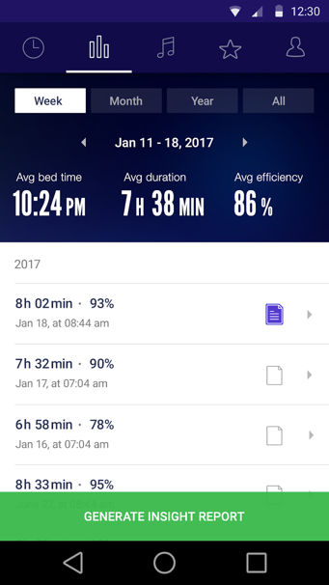 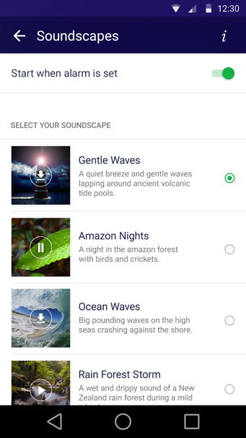

This app combines most of the functionality of all the apps listed above. It provides the user with a few statistics in various formats, alarms options based on sleep cycles and different audio queues for the alarms. This design was more detailed and professional which made it stand out from other more “cozy” designs.

Market Research Conclusion

Most of the apps were focused around allowing the user to improve their existing sleep by either augmenting their alarms with new features or by providing them with statistics about their existing circadian rhythm. This seemed to be a fairly saturated and developed market so there was little point me basing my app on what was already done well.

Some of the apps provided advice on how to improve their sleep but I believe they lacked the assertion to make some people actually take the advice. I will try to make my app more direct and assertive to make the user listen to the advice that it provides, especially due to the target demographic being students.

I also found that a majority of the apps that were on the market contained some sort of connotation to the word sleep. Our current app name is Blanket so if the app was to be released on the app store it would be a good idea to rebrand to “Sleep Blanket” or “Sleeping Blanket”, however the app design would be unlikely to change - just the app store name.

Requirements

Most apps already have functionality for statistics gathering, that market is saturated and has few gaps for a new app. If someone was to use our app it would have to be for a unique feature, as such we will instead focus on the sleep management aspect.

The app will plan out sleep schedules for the user by using their current sleep pattern and a goal that they set to gradually move their sleep schedule to a different period while preventing disruption to cognition during the day.

I did not find public APIs to gather or calculate this information for us so we will have to build the model ourselves.

To allow our app to be successful I have devised the following requirements:

|  |  |
| --- | --- |
| ID | Description |
| 1 | Allow users to select what time of day they want to aim to wake up. |
| 2 | Allow users to select what day they want to correct their sleep schedule by / or over how many days they want to correct the sleep schedule over. |
| 3 | Allow users to select how long they want to sleep for per night. |
| 4 | Allow users to enter what time they currently go to bed. |
| 5 | Warn the user if they select a low sleep length per night. |
| 6 | Send reminders when the user should go to bed. |
| 7 | Minimalistic design with colours liked with sleep. |
| 8 | Suggestions and advice should be assertive and direct. |

Requirements Justifications

Req 2 – This will allow the user to alter how sharply their sleep schedule will jump from day to day. It is important to allow them to control when the sleep is corrected by as some people will need to have their schedule altered for important reasons while others will simply like being able to have flexible goals.

Req 3 – Consistent sleep is important for better health.

Req 4 – This is to allow the app to design a personalised sleep schedule according to the time the user currently goes to bed. This will ensure the process is less jarring as the user alters their schedule.

Req 5 – Notify the user when the length of sleep is low due to health concerns.

Req 7 – The design should promote sleep through colour scheme and asset choices, less is more in our case as clutter doesn’t fit the aesthetic of a relaxing sleep app.

Req 8 – Despite the design being relaxing the advice should be less in suggestion form and more assertive, this requirement comes from the market research as I believe there is a gap in the market where most apps vaguely give advice and statistics rather than being direct about what the user should do (not counting sleep cycle alarms).

Target Audience

The app will be designed with a main target audience of students in mind as we often have our sleep schedules disrupted by deadlines and general lack of self-control, also being one myself I feel like I can relate to and understand what the demographic requires.

However, I will try to design the app in such a way that it is also attractive and usable for other users such as people suffering from jet lag after arriving from other time zones or preparing to fly to different time zones, as well as general people with poor sleep schedules.

Wireframes

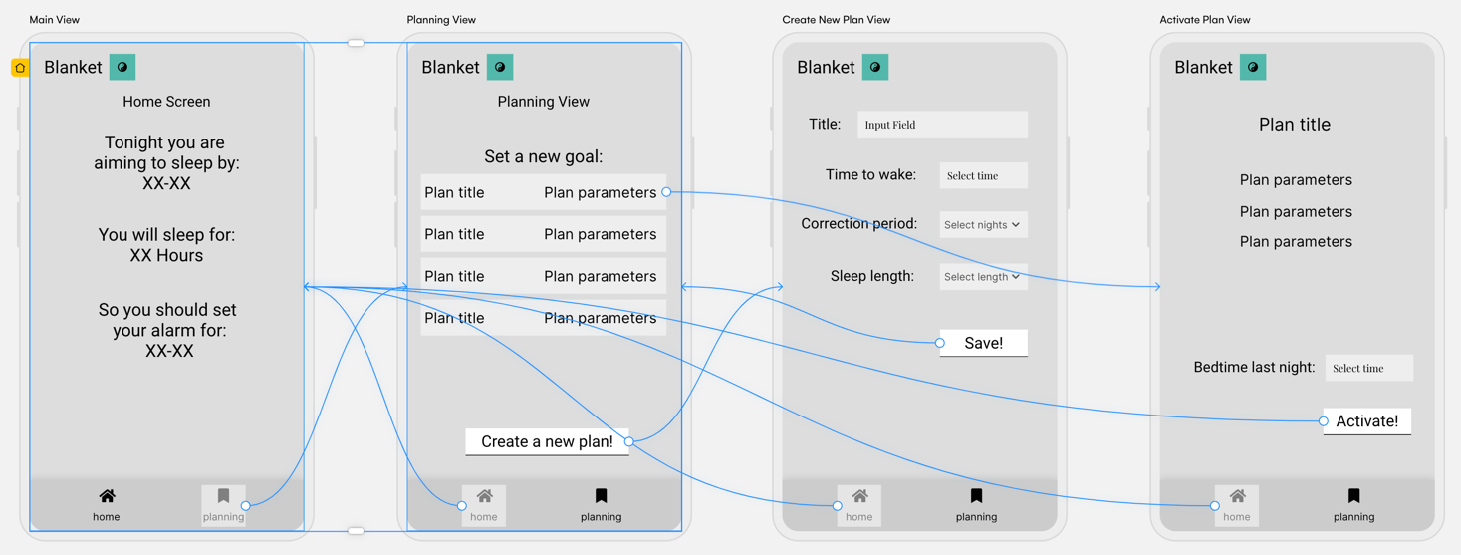

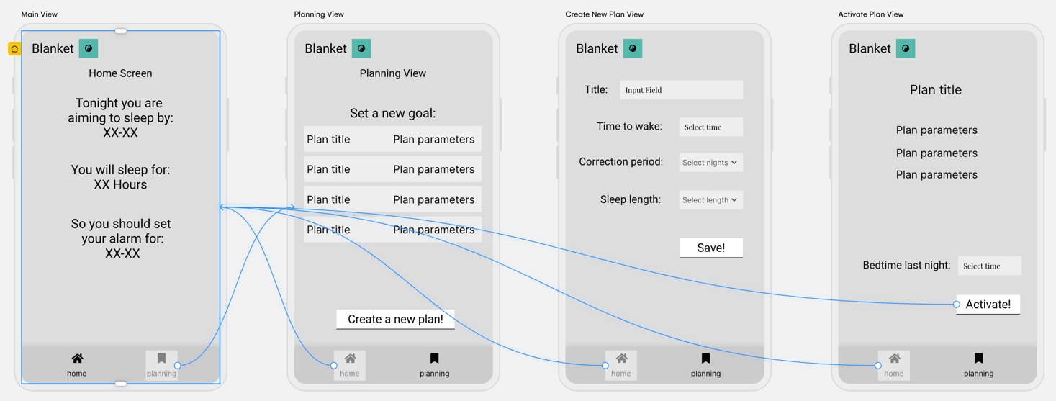

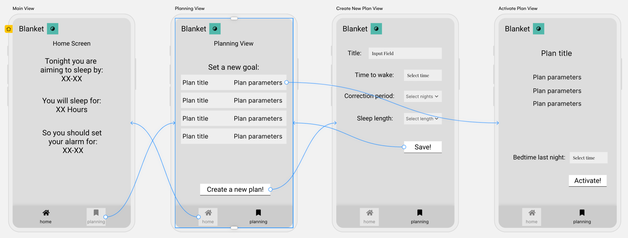

Wireframe Notes

The Main View will update the bed and alarm time dynamically as a day passes and the next target is set. When the final target bed time is reached, the app will stop changing the time and leave the corrected sleep schedule for the user to maintain.

When the user creates / saves a plan from Create New Plan View the new plan will automatically appear in the list of saved plans in Planning View. There will also be options to delete the existing plans from the list as well as potentially other editing tools such as moving the plan ordering around.

The user can save the components to a new plan by entering how long they want to sleep for, what time they want to get up in the morning and over how many nights they want to achieve the new schedule.

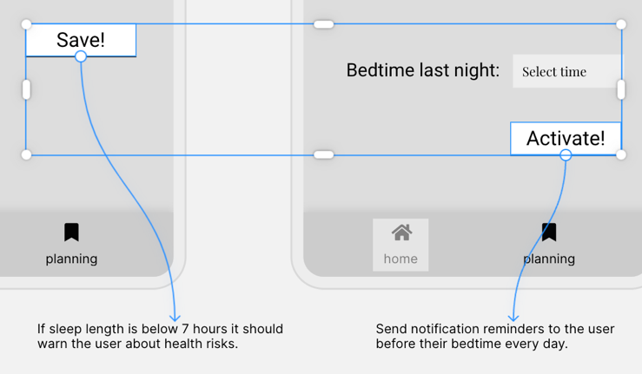The user should be warned and discouraged if they enter a low sleep length as it has negative health impacts, this can be done through validating the selected option when the user attempts to save in a Create New Plan View.

A new plan is mapped out and displayed once the user enters their bed time from the previous night and selects the activate button on the Activate Plan View. This active plan will appear on the Main View screen, showing the user the plan for the current applicable day.

Reminders will be activated behind the scenes when the user activates a plan in the Activate Plan View, the app will send notifications to remind the user to go to bed an hour before bed time.

All objects within the views will either be aligned with the centre or separated to the left and right sides of the screen with HStack / Spacer to allow for the views to function in different resolutions. This should mean that iPhones older than our required iPhone 12 Pro should work with the app, however depending on the composites design this may need extra work.

There is little to no reason for anyone to use the app in a landscape orientation as all the information fits on the current design. Due to this I will likely lock the app during development to make it more consistent.

The coloured symbol is a placeholder for the app icon. Also the colour scheme was specifically not considered during the wireframe, the following composites section covers asset ideas and colour design.

There are also plans for implementation of swipe action to make navigating the tab views feel more natural. This is likely to be something that is more obvious on an actual iPhone device rather than in the simulator of xCode which is why this has been specificly outlined here.

Composites

Colour Design

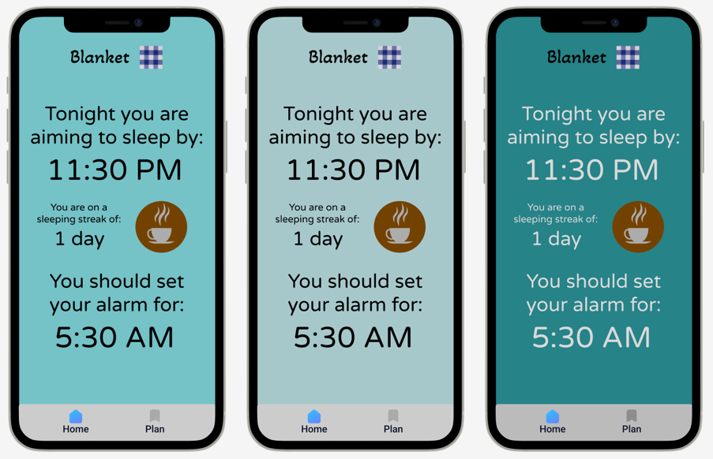

A range of different background colours were compared and tested with a high-intermediate artist (Tester 1). The initial ideas were to use a shade of blue as the background and change it over the course of the day, however after additional considerations and individual asset collection by the developer a consensus was reached to create two themes which would change dynamically depending on the dark mode of the user’s iPhone.

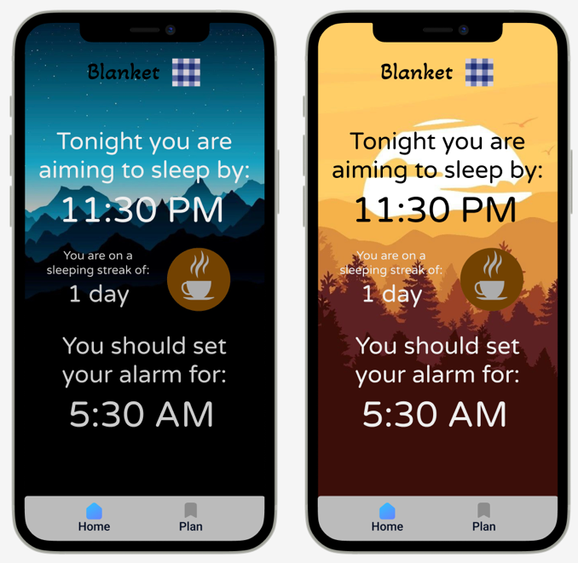

Composite Views

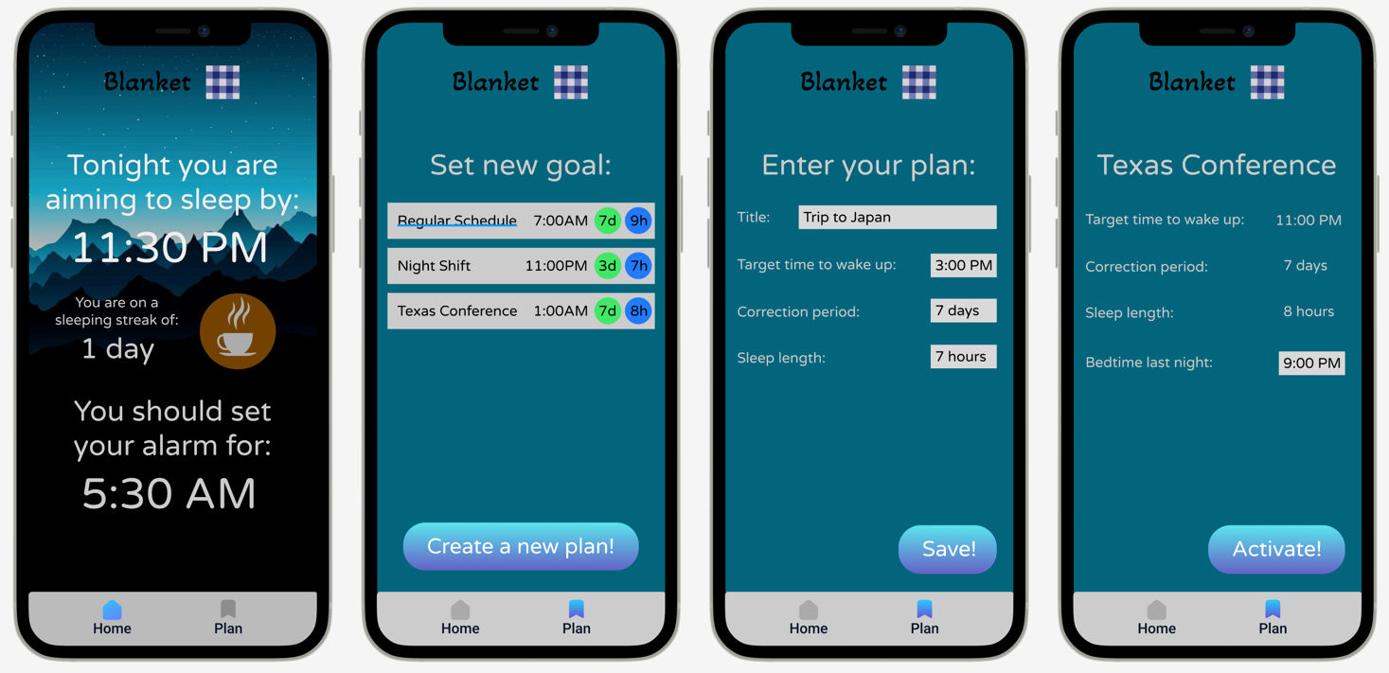

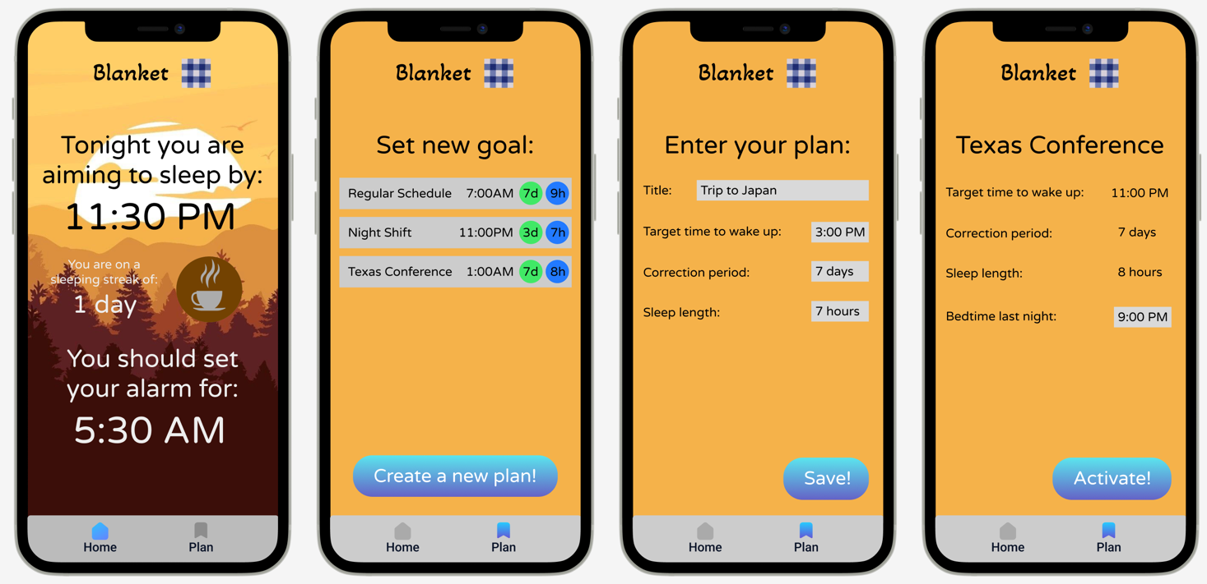

If dark mode is enabled on the iPhone, use the first set of views would be used and vice versa with the second view.

Composites Notes

The tab view style has been taken from similar sleeping apps after research, the design is simple and intuitive to navigate. The tab label will highlight when it is on the current view.

It should be noted that on the view where the user creates a new plan (screen 3), the app asks for the user to enter the length of sleep that they want to achieve rather than what time they want to go to bed.  
This is not a random choice but rather has been selected to promote good sleep by having the user consciously consider how long they will actually sleep for, rather than simply selecting a range between the time they go to bed and wake up.

The sleep streak is a suggestion by Tester 1, it would promote the user to maintain their sleep schedule but may be hard to implement as the system would need a way of confirming if the user is actually going to bed on time.

The image of the coffee asset is linked with the sleep streak, the image would change depending on the streak. For example if the user has gone to bed on time with the plan for 1-3 days the image displayed is of coffee, 4-6 days might be of triple z’s and 7+ could be of another blanket.

As mentioned previously, all objects and assets within the views should either be aligned with the centre or separated to the left and right sides of the screen. This will allow the views to function in different resolutions as well older iPhone models, this will have to be tested by the developer during development.

App Logo

The logo design was suggested by Tester 2, we considered a number of different potential designs but finalised on the second image due to the unique chequered pattern that some blankets have, as well as the icon appearing memorable.

